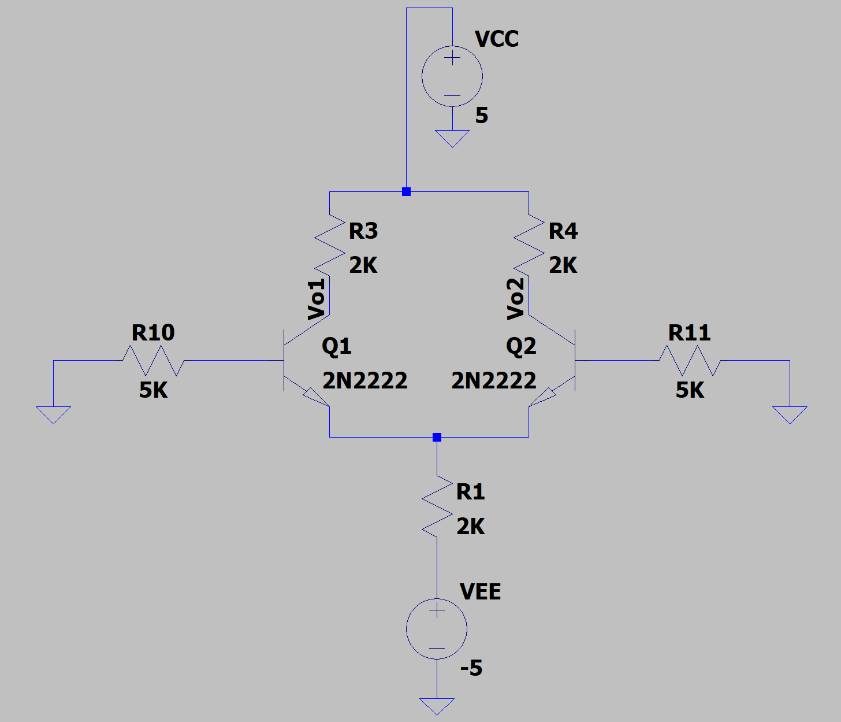

***We have:***













***Calculate Vo1 and Vo2:***



***Calculate gm1, gm2,*** ** ***and*** *****:***



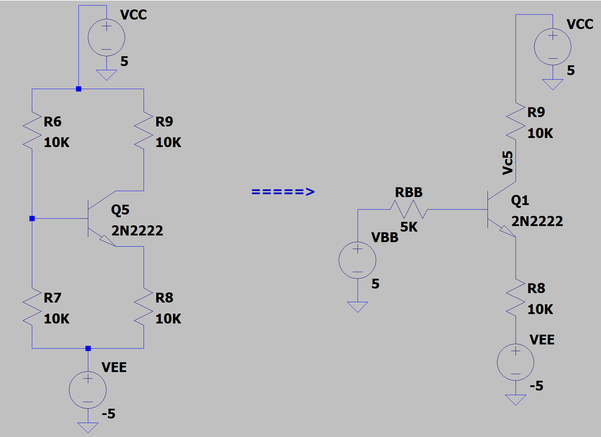

***We have:***



***Calculate VC5:***



***Calculate gm5 and*** *:*



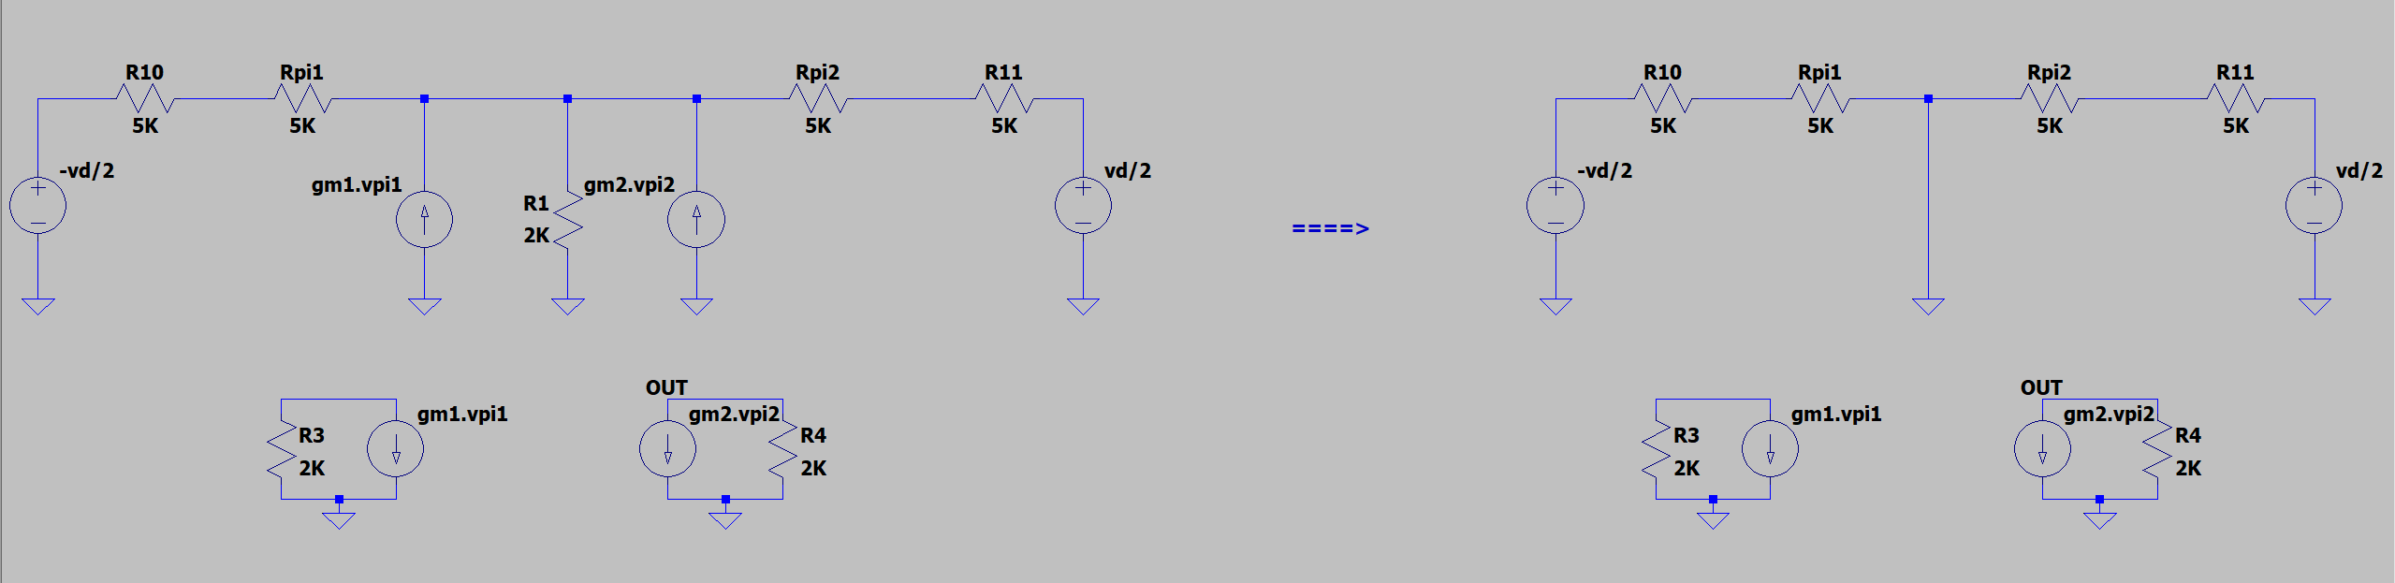



***Calculate vo,d:***



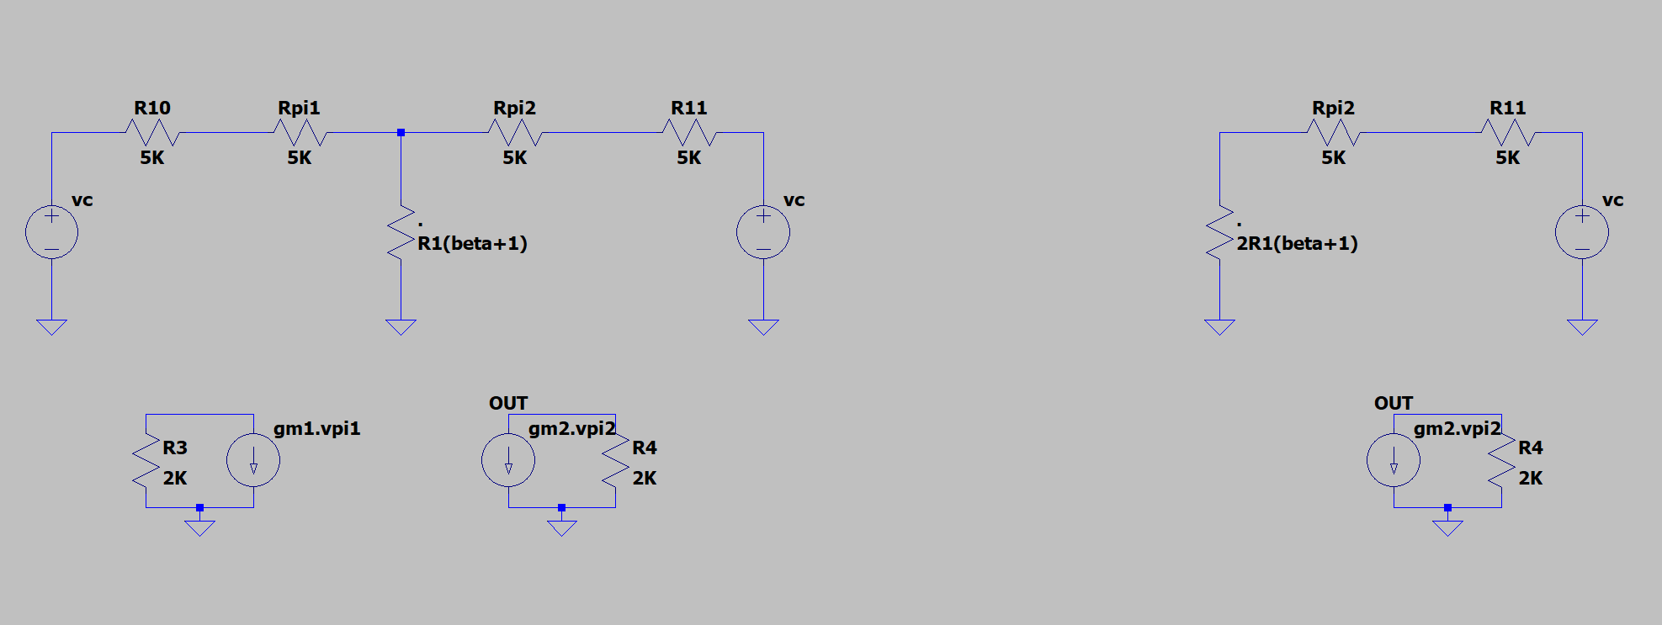

***Calculate vo,c:***



***We have:***

 

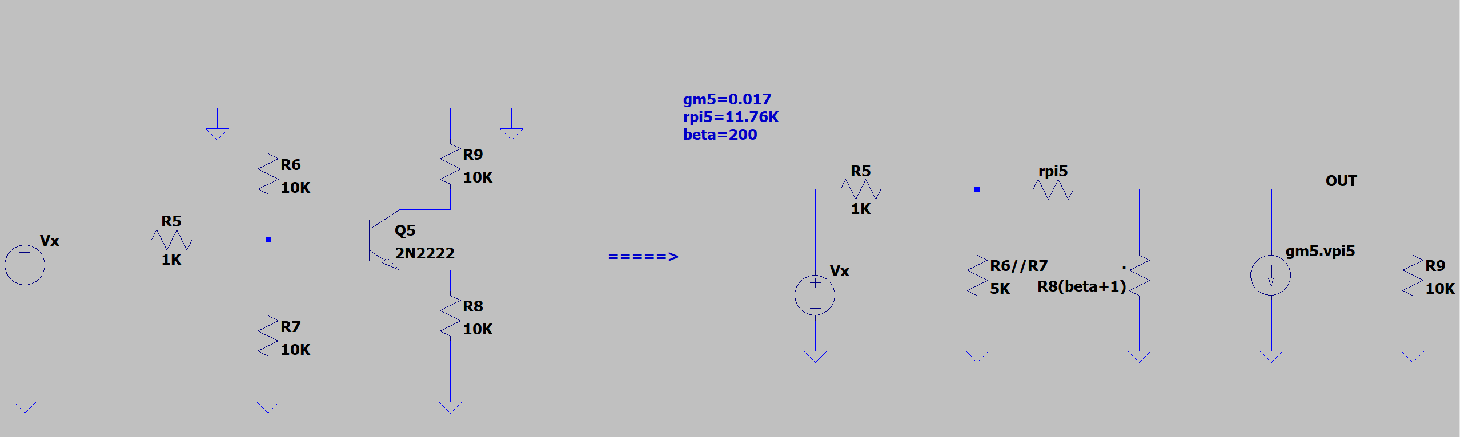

***We have:***

